Name Date Period Score _____/38

**NS Review INTEGERS**

1. *(3 pts)* Write the *addition* sentence modeled on each number line.

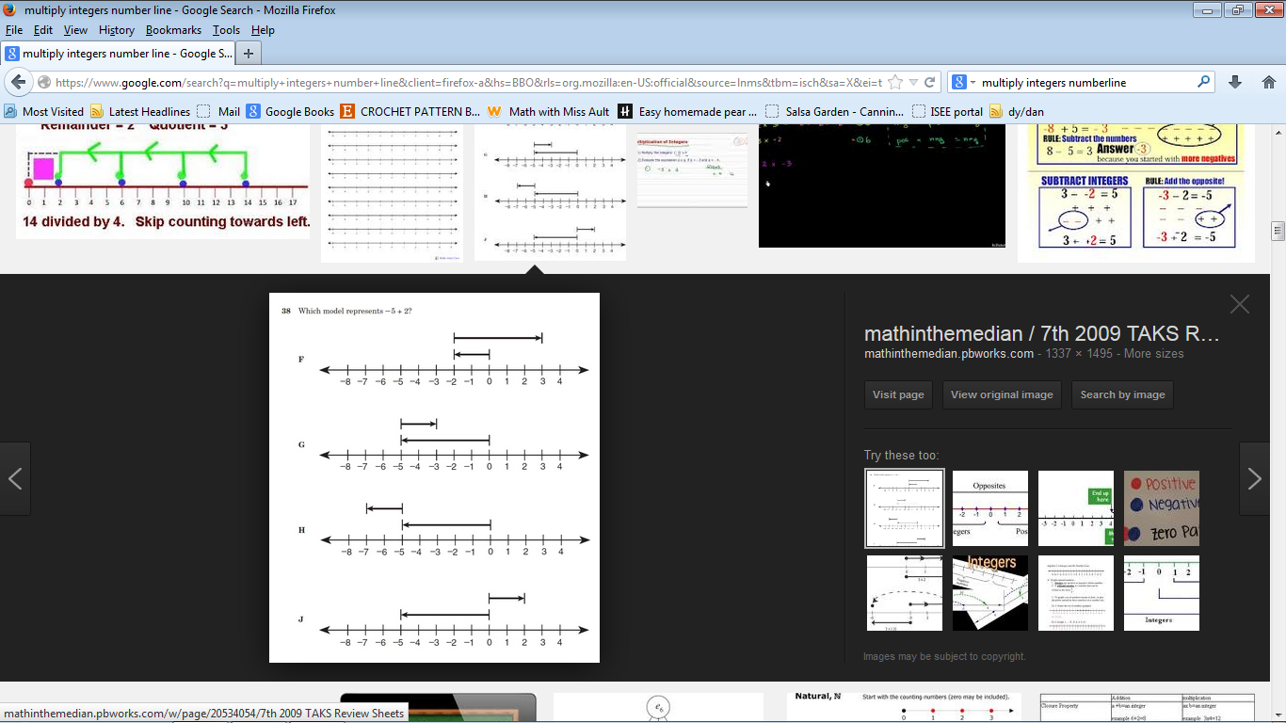

1. *(3 pts)* Complete the pyramid so that each number represents the sum of the two numbers directly beneath it.

-15

-20

5

-5

b.

c.

1. *(3 pts)* Jorge and Jordan were comparing the depths of two toy submarines. One blue one was 5 ft below sea level, and the orange one was 13 feet below sea level.
   1. Which submarine was at the greater depth?
   2. What change in the blue submarine’s depth would put it at the same depth as the orange submarine?
   3. Represent both submarines on the number line.

4. *(8 pts)* Fill in each blank with a number from the chart.  You may use the same number more than once.

|  |  |  |  |  |  |  |  |  |
| --- | --- | --- | --- | --- | --- | --- | --- | --- |
| **-5** | **-6** | **5** | **6** | **20** | **-20** | **-4** | **-36** | **☺** |

a.     _____ · _____ = -30                                  e) ______ + ______ = -10

b.     _____ · _____ = -20                           f) ______ + ______ = 1

c.      _____ ÷ ____ = -6                         g) ______ - ______ = 10

d.     _____ ÷ ____ = -4                             h) ______ - ______ = 14

1. *(3 pts)* Name 3 pairs of numbers with the product -4.
2. Explain why 85 – -73 is equivalent to 85 + 73.

“the same as”

*(3 pts)*

1. *(3 pts)* The EVMS Bobcats were on their own 45 yard line. For the next three plays, they lost an average of 4 yards per play. Where did the Bobcats end up after the three plays? Write the mathematical statement, show your work on the number line, write the answer.
2. *(3 pts)* Which integers, when added to 15 give a sum GREATER than 0? (Use the number line to show why)

8. *(3 pts)* Elliethinks that the **absolute value** of 3 is –3. Use the number line below to show and **explain her error**.

She thinks = –3



**9)** *(3 pts)* At 6am the temperature was –17ºC. In the afternoon the temperature was 13ºC. What was the change in temperature? Write the mathematical statement, show it on the number line and write the answer.

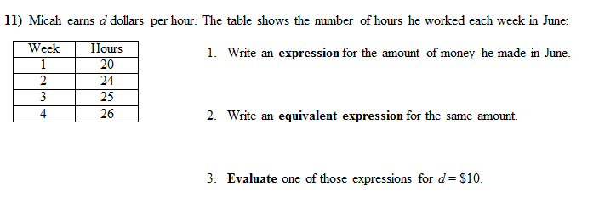

**10)**