Context | Model | Equation | Inverse Operations
Today is Rosa’s 12th birthday. She has a savings account with $515 in it, but her goal is to save $10,000 by the time she turns 18. How much money should she add to her savings account each month to reach her goal of $10,000 between now and her 18th birthday?
 |  |  | 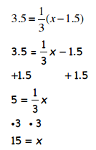
 |  | 5(b + 2) + 3b = 42
Calisa’s grandpa won’t tell her how old he is. Instead he told her, “I’m twice your mom’s age.” Calisa knows her mom had her when she was 24 and Calisa is now 12. How old is Calisa’s grandpa?
 | 